r. No. | Symbol | Name | File | References
1. | Flag | Flag of the United States | 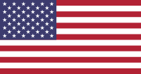 | ^{[1]}
2. | Seal | Great Seal of the United States | 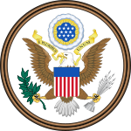 (obverse)  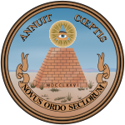 (reverse) | ^{[2]}
3. | National animal | Bald eagle | 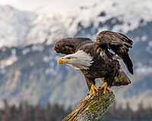 | ^{[3]}
4. | National mammal | American Bison | 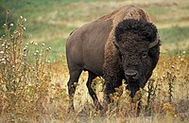 | ^{[4][5][6]}
5. | National anthem | "The Star-Spangled Banner" | "The Star-Spangled Banner" | ^{[7]}
6. | National motto | "In God We Trust"  E pluribus unum |  | ^{[8]} ^{[9]}
7. | National floral emblem | Rose | 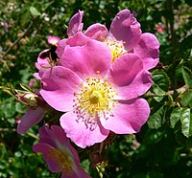 | ^{[10]}
8. | National march | "The Stars and Stripes Forever" | "The Stars and Stripes Forever" | ^{[11]}
9. | National tree | Oak tree (Quercus) | 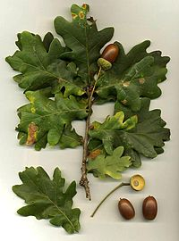 | ^{[12]}
10. | Oath of Allegiance | Pledge of Allegiance | 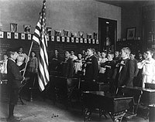

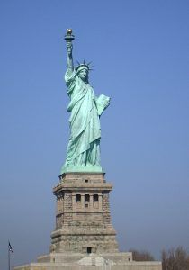

The Statue of Liberty – With the formal title of “Liberty Enlightening the World, the statue was a gift to the United States from the people of France. Dedicated in 1886, the statue shows Libertas, the Roman goddess of freedom. Located in New York Harbor, the statue holds a torch in one hand and a tablet representing the law in the other. The date of the Declaration of Independence is inscribed on the tablet. A broken chain sits at Libertas’s feet. The statue is an iconic symbol of freedom. Protestors worldwide have used the statue’s image in their struggles for political freedom.

Uncle Sam – With the initials “U.S,” Uncle Sam is a common national personification of the U.S. federal government or the country in general that, according to legend, came into use during the War of 1812. The name is linked to Samuel Wilson, a meat packer from Troy, New York, who supplied barrels of beef to the United States Army during the War of 1812. He is portrayed as an older, bearded man dressed in clothes that evoke the U.S. flag.

https://www.youtube.com/watch?v=N_lCmBvYMRs

